**Experiment 12**

**Aim:** Configuration of docker and starting its container in vagrant.

**Procedure:**

**Step 1:** In order to ensure the downloads are valid, add the GPG key for the official Docker repository to your system.

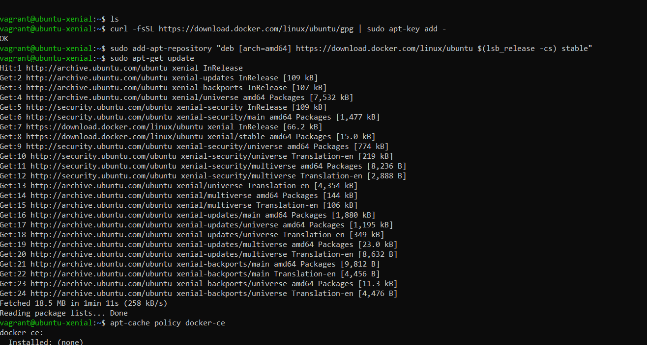

**Step 2: A**dd the Docker repository to APT sources.

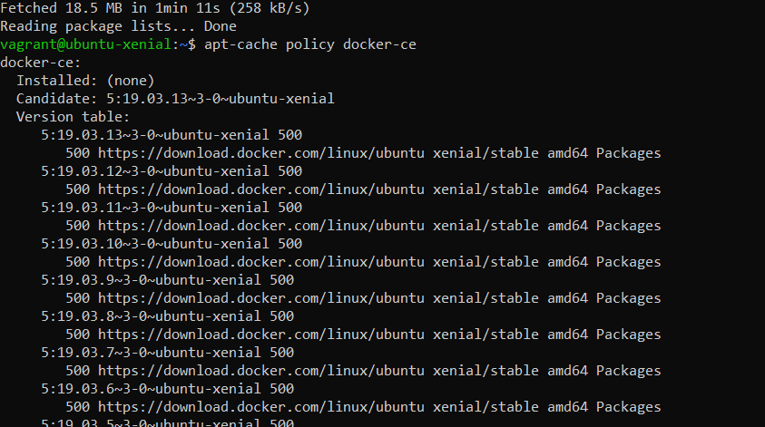

**Step 3:** Update the package database with the Docker packages from the newly added repo and update the policy.

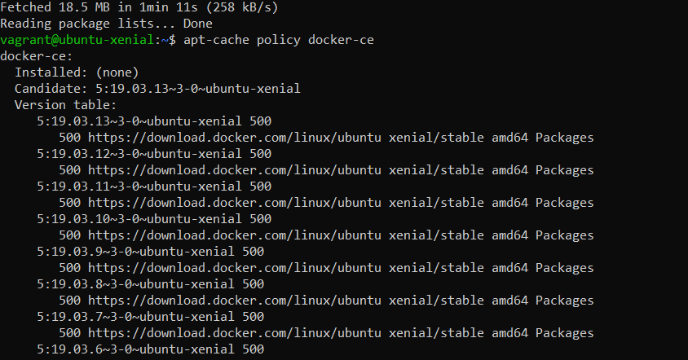

**Step 4**: Now install docker.

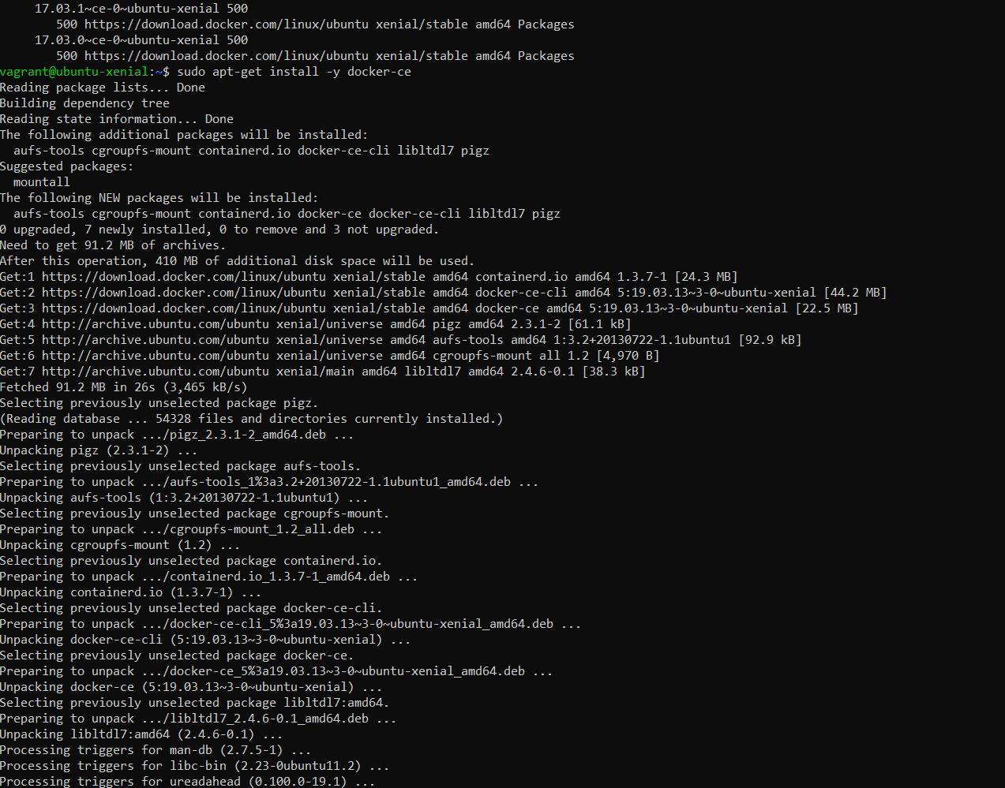

**Step 5:** Verfiy that docker has been configured using the ‘systemctl status docker command’.Create a user for using docker. Create a docker container using the Ubuntu image

The command to be used ‘docker run –it –name check ubuntu.’ The following command will fetch the ;astest image of Ubuntu from dockerhub and create a container via this image.

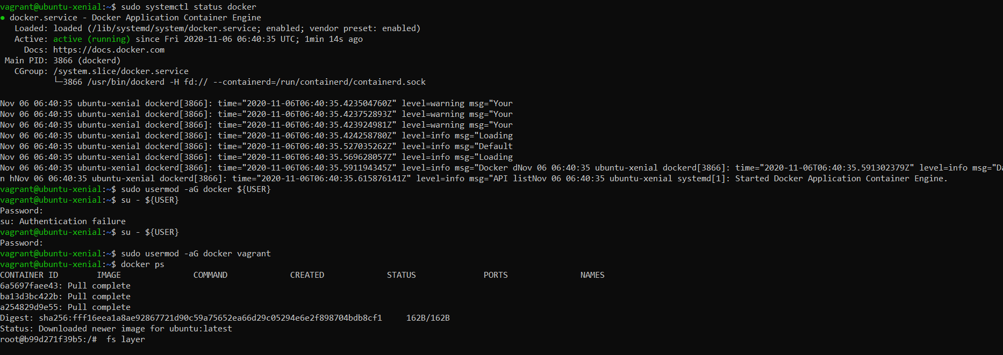

**Step 6:** Once the container has been launched it can be verified using the docker ps command.



**Step 7:** Exiting the container.

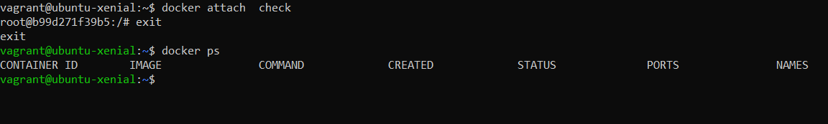

**Submitted by:**

Arjun Rekhi

500068109

R171218028